XHAW5112
Group 4
Angel Tshilidzi Shirilele ST1048276712
Lufuno Maiwashe ST10489459
Thendo Mamphogoro ST10482700
Rebatho Mphela ST10477128

1. Description of clients needs
The client, Precious Radebe, requires a web page and a mobile application to effectively advertise her skills training business. These platforms must have identical functionality and provide a seamless user experience.
The primary goals are to:
-Advertise Services: Publicize the six-month Learnerships six-week short skills training programmes offered to domestic and garden workers.
-Receive information Request: Allow potential customers (employers or employees) to request information and quotes for services.
-Provide Course Details: Display a comprehensive list of courses with hyperlinks to detailed pages for each.
-Facilitate Fee Calculation: Include a form where customers can select courses and receive a total quoted fee, which must include applicable discounts for multiple courses and 15% VAT.
-Generate Invoices: Store a customer’s course selection to prepare an invoice upon verification.
-Display Contact Information: Provide essential contact details, including a phone number, email address ,etc.
-Ensure Navigation: Both platforms must feature a drop down menu for easy navigation and include robust error handling for user inputs.

2. User-Centred Design
A user-Centred Design process will be used to ensure the web page and mobile app are intuitive, accessible and meet the needs of all the users, including those who may not be highly tech savvy. The process will involve:
- User Research: Understanding the target audience (domestic and garden workers, as well as their employers)through surveys or interviews to determine their needs, preferences and digital literacy.
- Information Architecture: Creating a logical and easy-to-follow site map and navigation structure.This will ensure users can find course details, fee calculators and contact information with minimal effort.
- Prototyping and Testing: Developing low-fidelity wireframes and high fidelity mockups that will be tested tested with a small group of users. This feedback will be used to iteratively improve the design before development begins.
- Accessibility: Ensuring the final design has clear typography, Sufficient color contrast and an intuitive layout to be accessible to users of all ages, including elderly individuals.
3. Wireframes for Web Page and Mobile App

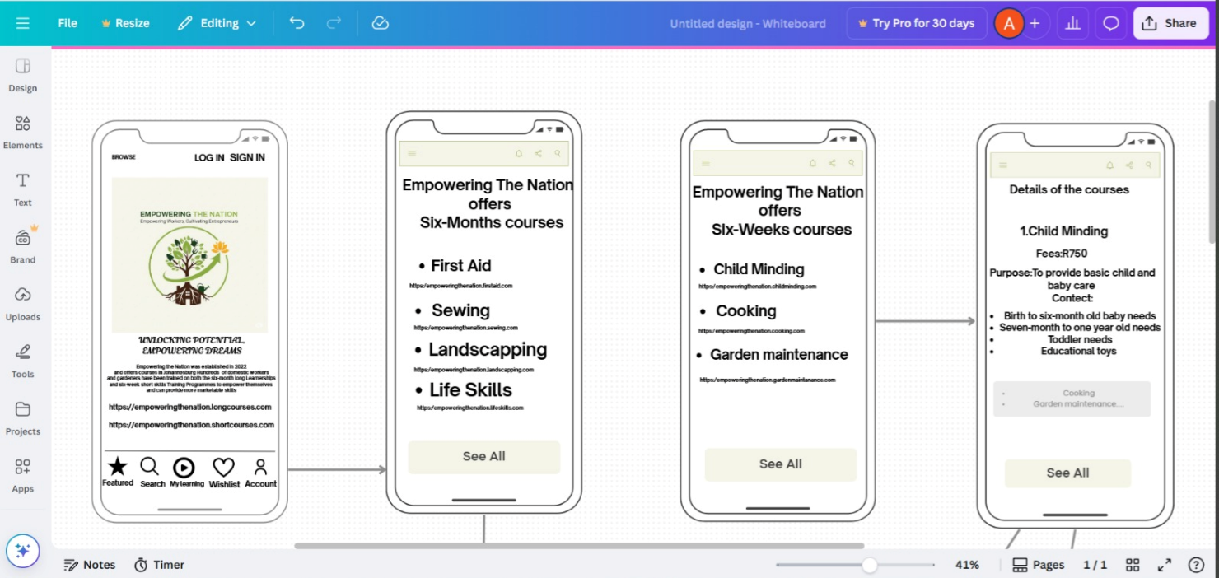

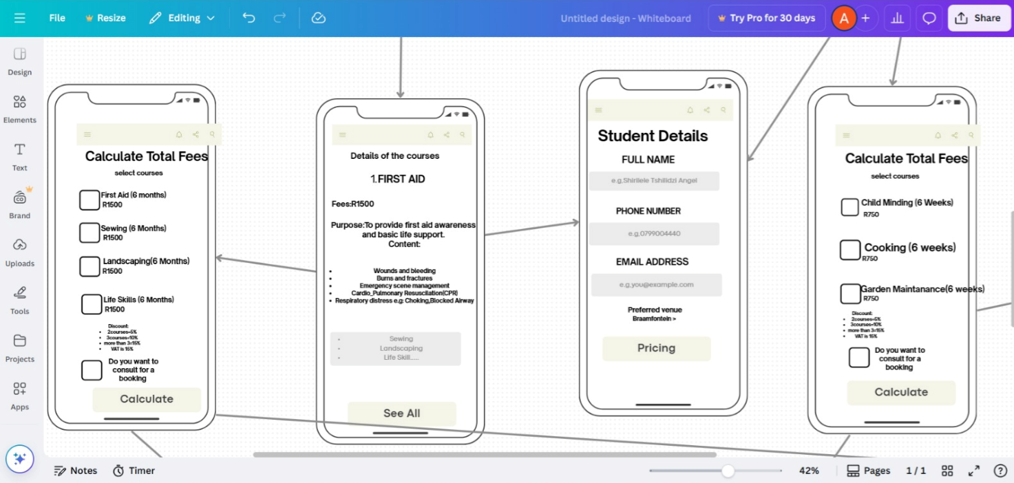
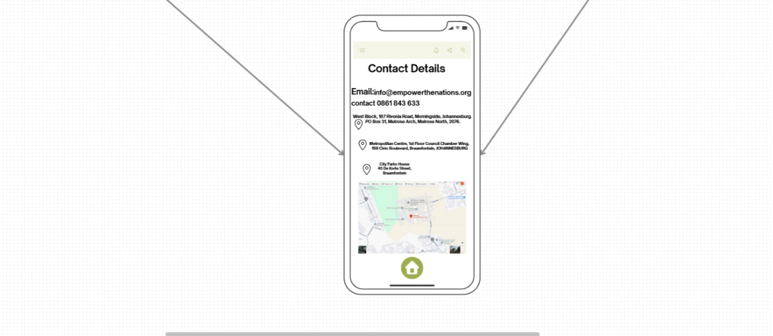

Wireframe for Web Page
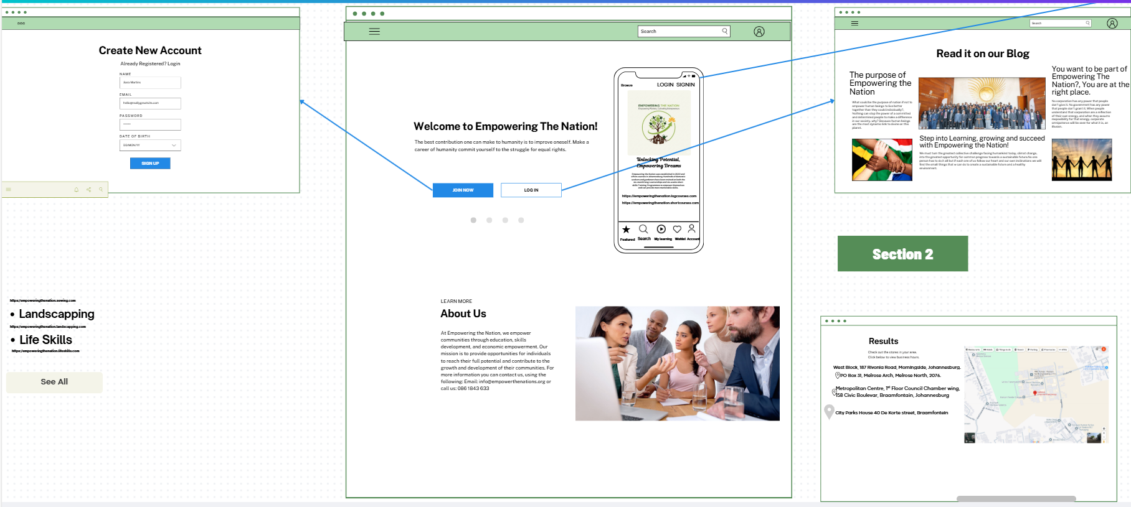
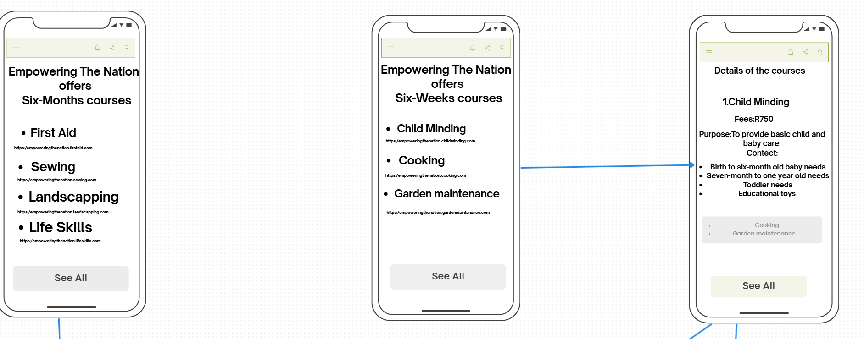

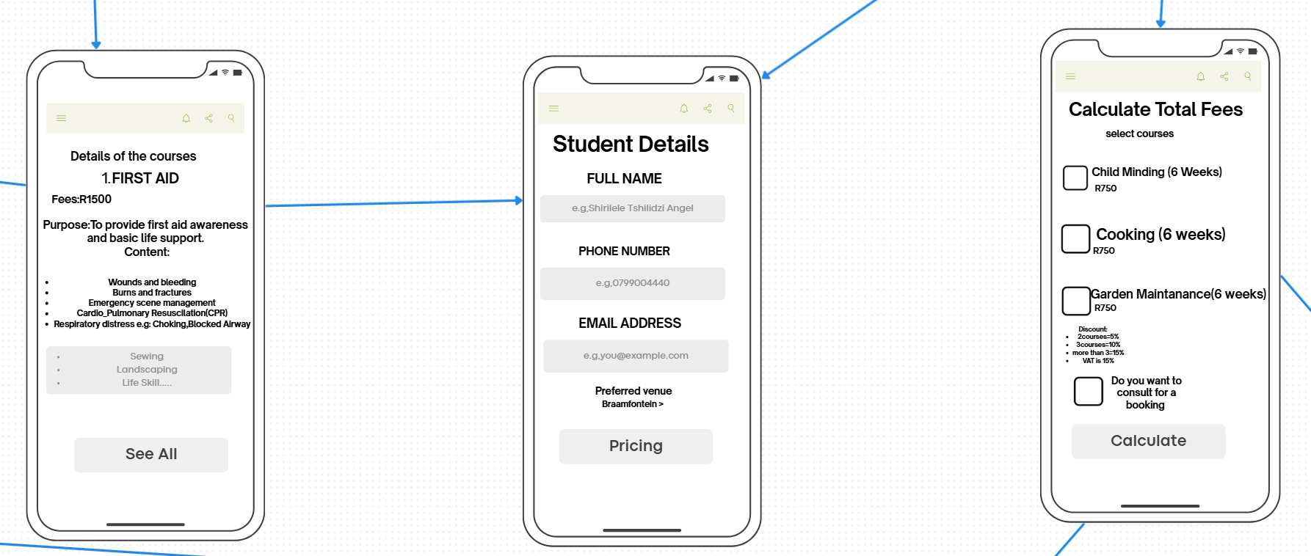
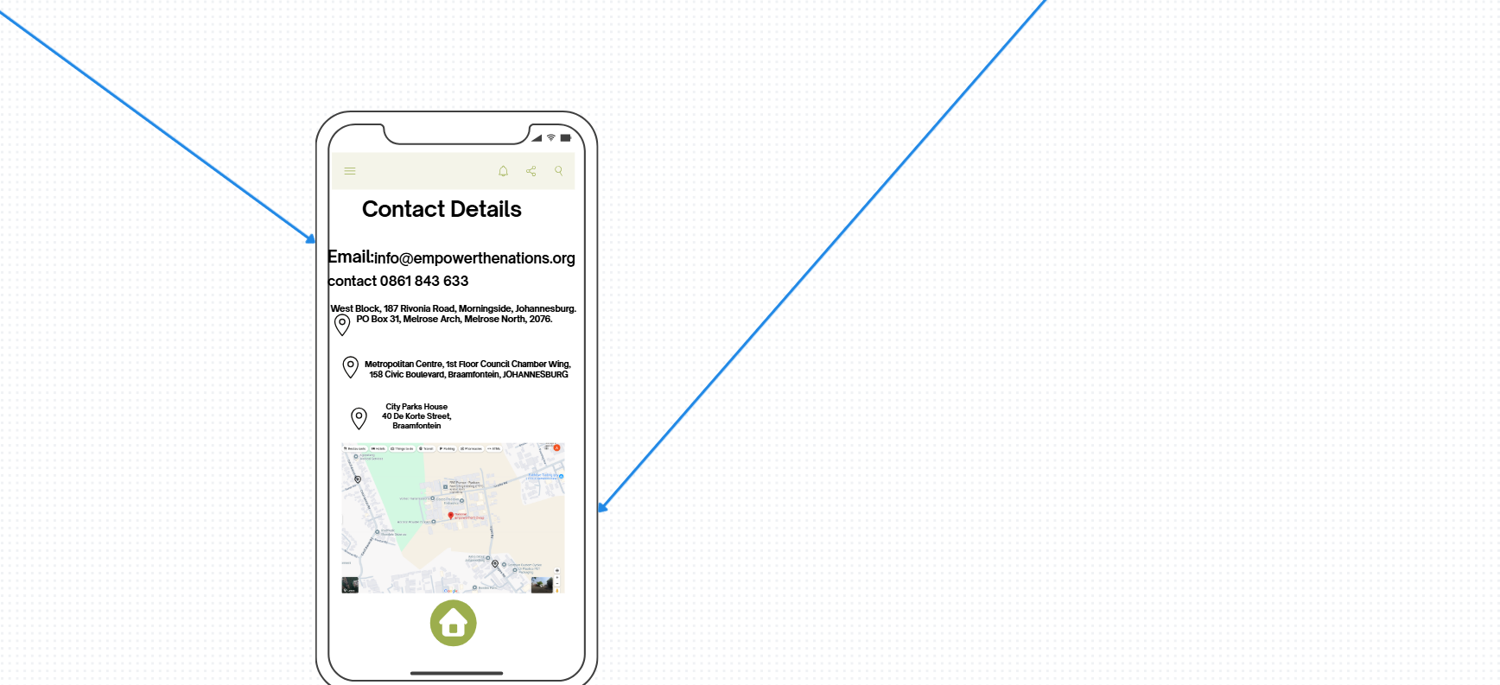
LOGO
